**Open Coorporation Crawler Manual**

**1-Installtion:**

**-**Double click the setup file

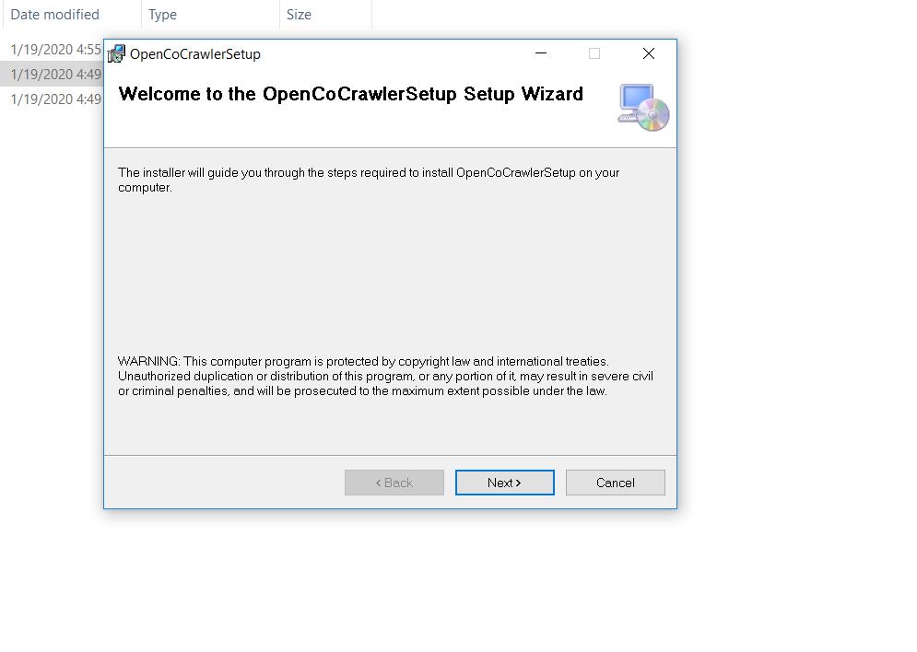

-Click the Next Button

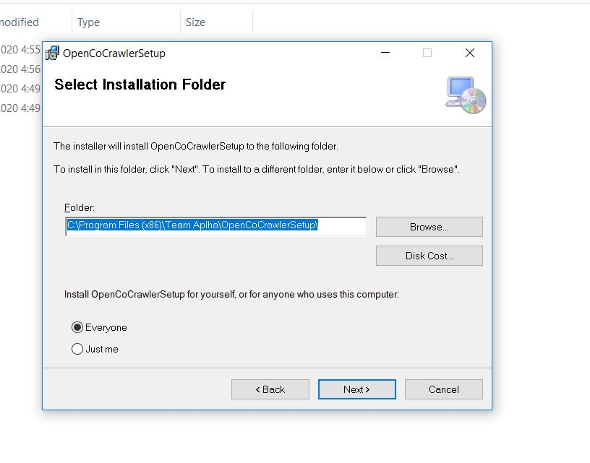

**-Save the installation path . You will need it later.**

-Follow the Next Setup Steps

**2 – After Installation :**

-Goto the Installation folder you saved in previous step.

-Open ‘OpenCoCrawler.config’ file in Notepad ++ or any other text Editor

- Change Following Keys According to your system.

**ExcelFilePath**

It is the path of file you need to read. The path should have complete file name with Extension.

**SalesRecordSheetName**

Name of the sheet(Tab) where sale orders are saved.

**CompaniesRecordSheetName**

Name of the sheet (Tab) where companies names list is saved.

**OutputFilePath**

Name of the directory where you want to get output file. Do not write file name here, Application will create, delete and update these files by itself. Application will also give them proper names.

**CompanyTypes**

Comma separated list of Names you want to keep in companies list. Seperated the each name with comman and no spaces. It is not case sensitive (Lower/Upper case does not matter).

**Delay**

Value in seconds. The crawler will wait of these second before making any API call. To fetch details of one company crawler need to make 2 calls. So 2s delay means crawler will take upto 5s-6s in crawling data for one company.

**3- Before starting Application:**

-Make sure you have installed latest version of M0S Office. If not or if Application gives ‘Oledb’ related Exception. Download the OledbDrivers x86 from following link.

<https://www.microsoft.com/en-gb/download/details.aspx?id=13255>

-Scroll down page and click Red ‘Download’ Button.

- Choose ‘AccessDatabaseEngine_X64.exe’

- 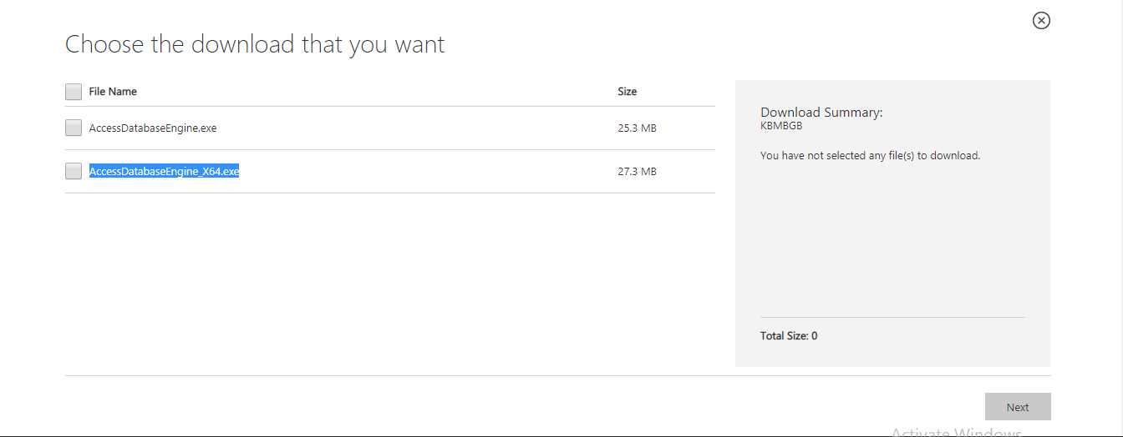

Download and Install setup:

**3- How to Use:**

* Goto to Installation path and run the app by double clicking the .exe file.
* Use proper command
  + 1 :
  + 2
  + 3
* The Application will show the process and also the output file names with proper path.

**4 - NOTES :**

**-**Give all paths correctly

**-CLOSE & DO NOT OPEN ANY INPUT OR OUTPUT FILE DURING THE PROCESS**

**-**Incase of any error. Take the screen shot of output screen and sent it to developer.